An important part of your ACME Grant Eligibility and Application forms are your work samples. Work Samples help to provide additional information and evidence of your work to supplement your application.
Eligibility Work Sample
In the eligibility section of the application, you will be asked to provide evidence of your creative production work history in Austin.
All eligibility work samples MUST clearly identify:
- The applicant entity and their role in producing the event in the sample.
- The venue of the event (name of venue and/or address). The venue MUST be in the City of Austin Council Districts or Extra Territorial Jurisdiction.
- Event date (must include a month and year).

A Work Sample that does NOT confirm eligibility

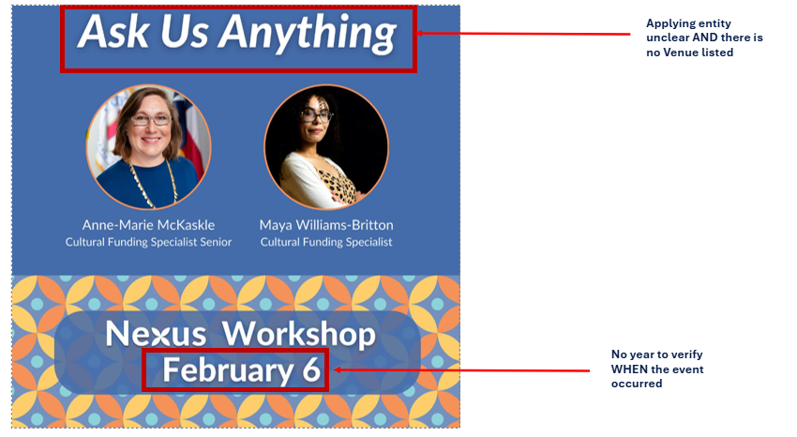
X - It is not clear who is hosting the event
X - The date does not have a year listed
X - There is no venue.

In the work sample below, you can see the flyer does not have all the required information. Since the required information is missing from this work sample, the application may be deemed ineligible. Staff will verify eligibility solely on the work sample provided and will not consider additional documentation.
A Work Sample that DOES confirm eligibility

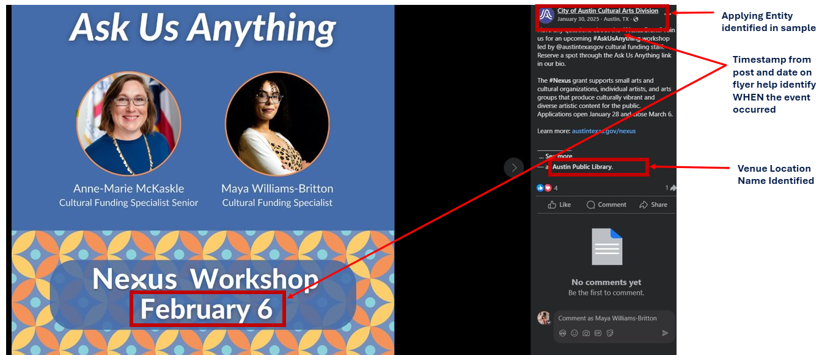
This sample includes the flyer and a social media post description, which provides additional context: who produced the event, what the event was, the date it was marketed, and where it was hosted. All of these items will be required for staff to verify your history of producing public artistic events in Austin.
Things to keep in mind when selecting your Eligibility Work Sample:
- This work sample is NOT SCORED. You do not need to spend a lot of time choosing your best work sample. Choose something that has all the required information.
- Do not upload a photograph of an event or person by itself. A photo alone does not clearly tell us what the event is, where it was, or when it occurred. If you upload a photo, provide a 1–2 sentence description explaining the when, where, and what.
- Social Media Screenshots make great work samples. If your event flyer does not include a year, take a screenshot of a social media post. Ensure the date the post was made is clearly visible.
Application Work Sample(s)
Your application work sample(s) will be used to determine a score for the question it is tied to. Reviewers are instructed to spend no more than 5 minutes on one work sample, so it is important to select one or two samples that supplement your narrative and clearly highlight what you want the reviewer to see.
Things to keep in mind when selecting your Application Work Sample:
- Put your best samples forward. Choose high-quality samples (not blurry or hard to read) that support your narrative.
- More is not better. Reviewers will not spend more than 5 minutes per work sample section. Curate your uploads and avoid overwhelming reviewers with multiple links and documents to look through.
- Provide Context. Include a 1–2 sentence description explaining what the work sample is and what you want the reviewer to focus on.
- Avoid repetition. Do not use the same work sample for every question if multiple uploads are required.
Example Application Work Samples
Strong Work Samples
- Short videos (5 minutes or less) of past projects similar to work described in the application. Videos should NOT be password-protected.
- Photos of past work with descriptions.
- Links with descriptions directing panelists to specific areas of your website or social media (e.g., “Please review the ‘About Us’ section of our website to learn more about our team” or “Review my most recent Instagram post”).
- Board lists or project team biographies.
- Past marketing and engagement plans or sponsorship decks with impact numbers.
- Letters of Recommendation from audience members or other community members who can speak on the impact of your work.

Work Samples that are LESS strong
X A long list of links.
X Photos with no description or clear connection to the narrative.
X Work samples that do not relate to the question being asked.

Final Tips
Applicant Checklist
Before submitting, confirm:
- Does your eligibility sample include:
  - Applicant name or role
  - Austin venue
  - Date (month/year)
- Is your application sample high-quality and relevant to your narrative?
- Did you provide descriptions for each sample?

Technical Tips
- Recommended file formats: JPEG, PNG, PDF.
- Provide links to Audio or Video Work Samples rather than uploading.
- Work Samples should be no longer than 3 pages or 5 minutes if a video/audio sample is provided.
- Maximum file size allowed: Check application instructions.
- For screenshots: Make sure the date and context are visible.
- Test all links before you submit. Staff will not contact you if a link is broken or inaccessible.
- Avoid password-protected videos or files.
- Review the suggested uploads. Staff provides recommendations for the types of work samples that may be applicable to your narrative in the helper text of the upload description.

